Clinical Feedback meeting notes by Goutam Reddy (greddy@abiogenix.com)

4/6/20 meeting @ Stanford Health (they run the drive-through swabbings)

Interviewed: Dr. Linda Barman, Thanh Khong PAC, Multiple other Stanford Physicians

Summary of Design Notes:

1. Really like black material
   1. it’s a little more springy
   2. feels better (smoother)
   3. is more flexible
2. Recommendations:
   1. liked pre-flex, said could be a “little less”
   2. thicken breakpoint (okay to bend and twist to break off into tube)
   3. move breakpoint down to 100mm
   4. move neck-body interface down (by 2cm)
   5. liked roundness of head
   6. wondered whether spring head will pick up enough material
   7. **want to test against spiral**

Swab Note:

Again- wanted 100mm break-point with neck moved down by 2cm.

General Notes:

1. Asked about catching: yes, catching and bending on an obstruction happens
2. New people will push up instead of down and will kink the head sometimes
3. Tested for max-torque (torque wrench + socket bit + thermosteel + dremel chuck)
   1. max torque is definitely below 5lbf-in (minimum of test tool)
   2. estimated to be below 3lbf-in.

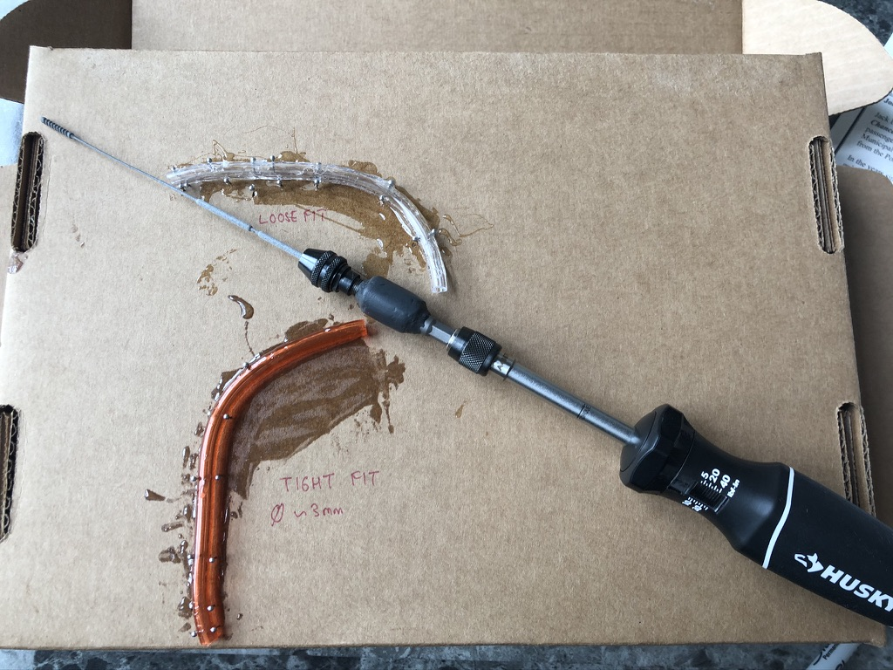

Test 25) HP Spring Black Vapor 80mm (mfg by HP in San Diego)

* autoclaved at 121 at LLNL

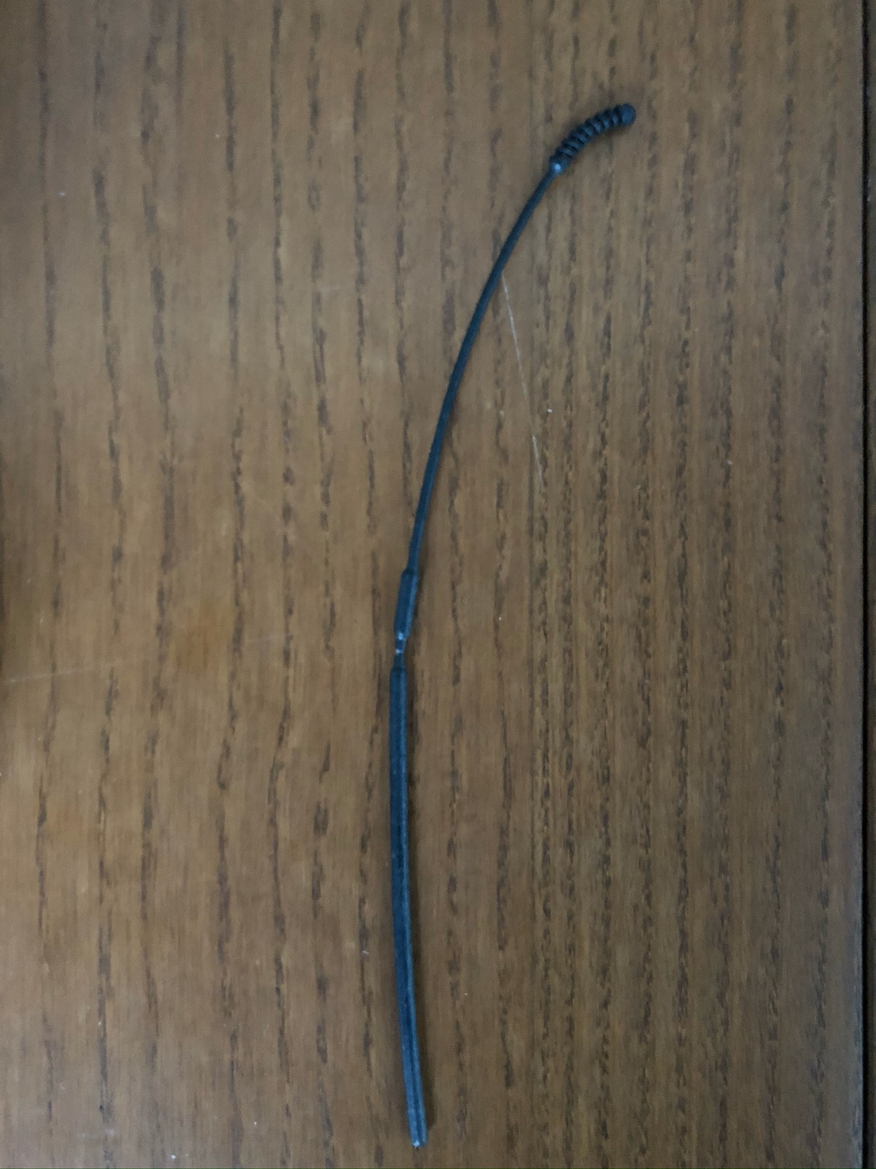

* breakpoint: make much harder to break still
* breakpoint: give it a chunkier waist
* breakpoint: minimal scoring -> much shorter cut
* breakpoint: only thin it out a little more
* a tiny less curvature to bend
* is tip “too smooth”? will it pick up material
* will the spring collect enough material
* can make a hole in middle of it (discussed previous design that had hole, but was too sharp)
* like black material: more springy, more flexible, better feel, like springiness
* 